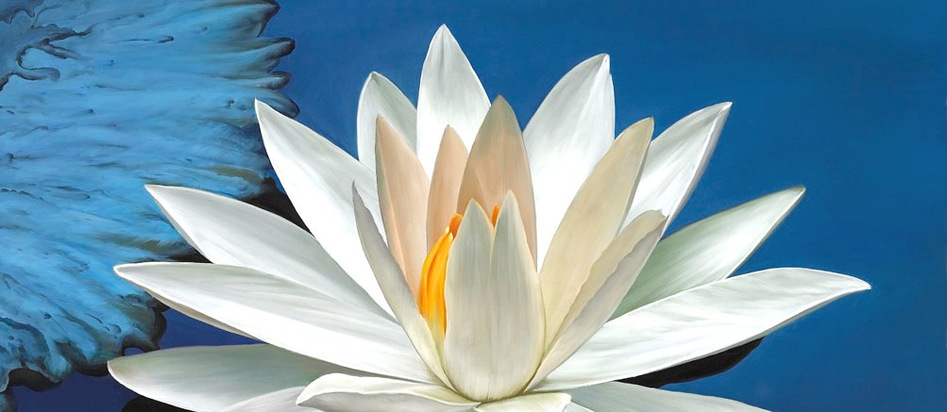

Diamond Heart Quantum Awakening Workshop
August 2, 1-4 PM Central

Explore the Flowering Heart Path with us. Experience the Flowering Heart Blessing, Diamond Heart Light Body Activation, Quantum Awakening & God Realization and the Flowering Heart (Open Eye) Light Meditation.

We will use various Sacred Processes, Teachings, Mantras & Meditations that free us from the reactive mind, negative emotions & psychological programming, to help us dive deeply into the sacred space of the Heart, unconditional love, higher consciousness & oneness with the divine. We will receive Grace to tune us to the highest possible frequency and to illuminate our Spiritual Heart with the Diamond Light of Love, Grace & Enlightened Consciousness.

Together we will make a Quantum Leap deeply into the Spiritual Heart. Here our True Sacred Self, our Original Nature of enlightened awareness, clear intuition, wisdom, unconditional love & genuine connection with the inner Divine all spring to life within us!

When we encounter and embrace the divine spark within us, the Diamond Heart is born (sometimes called diamond body, rainbow body, diamond vehicle, vajrayana, golden flower, immortal embryo, merkaba and many other names).
Our journey together will include a Diamond Heart Light Body activation, and initiation as a Flowering Heart Blessing Giver (Hridaya Vikasa Diksha) with the ability to initiate others as Blessing Givers. We will conclude the workshop with a Flowering Heart (Open Eye) Light Meditation.

The Flowering Heart Blessing (Hridaya Vikasa Diksha) is a powerful catalyst for transformation. It is a transmission of divine energy, grace and enlightened consciousness that flows directly from the divine source. It is fully interfaith and does not belong to any spiritual or religious tradition, teacher, master, organization or hierarchy. It is free of cost and supports all paths. This powerful blessing awakens enlightened consciousness, unconditional love, compassion and connection with the divine within one’s own spiritual heart, causing it to flower in a beautiful process of transformation.

When we discover the divine Presence within us, we begin to see our true sacred self, our original nature and our genuine inner teacher, and we are freed from seeking something outside of ourselves. We will cease giving away our power, through an enslaving dependence on external teachers, groups, beliefs, practices, rituals and places of power. We will stand free in the realization of our own inner divinity and enlightenment, pouring out unconditional love, compassion and grace to the world. This is the Spiritual Heart of Liberation.

Join us for the journey of a lifetime!

This retreat will include:
Flowering Heart (open eye) Light Meditation
Flowering Heart Blessings to Awaken Divine Light & Love in the Spiritual Heart
Diamond Heart Light Body Activation
Tibetan Om Mani Padme Hung Mantra Initiation & Meditation
Meditation to raise Kundalini (divine energy in the body) & clear the Chakras
Processes to clear thoughts, emotional charges & psychological programming
Quantum Realization of Divine Union & Enlightened Consciousness
Activation/Initiation as a Blessing Giver & to initiate others & lead groups

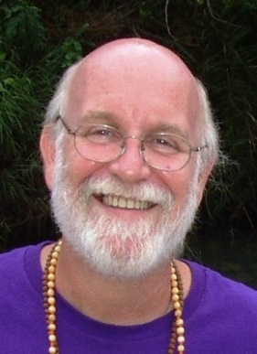
Rev. Dr. Michael Milner, Ph.D. is a Spiritual Teacher & Counselor & Interfaith Minister, who embodies diverse spiritual traditions: Taoist, Christian, Hindu, Buddhist and more. For over 40 years Michael has provided counseling, guidance & energetic assistance to those who are undergoing processes of spiritual transformation.

Michael is an Interfaith Minister, ordained in both the Taoist and Christian traditions. He helps people from many paths flow with the effects of the awakening process. Michael and his wife, Rev. Suzanne Champlin, co-direct Flowering Heart International Holistic Spiritual Center in Clearwater, Florida. Visit: http://floweringheart.org/

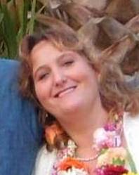
Rev. Suzanne Champlin is a Spiritual teacher and counselor, ordained Interfaith minister, divine healer, Reiki master and artist who has been on the healing path for 30 years. She has a BA in Psychology and has worked with children and adults helping them heal.

Suzanne is initiated in 3rd Degree Reiki, Tao Ahn Pai Qigong, Ananda Jyotir Diksha, Ishayas Ascension, Chikara-Reiki-Do, Jain Gnan Vidhi, Oneness Deeksha, Flowering Heart Blessing and her own energy Healing System. Those who experience her healing sessions report wonderful results.

